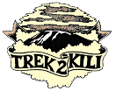
Trek2Kili
P.O. Box 2112 Moshi TZ
Cell+255673360715
trek2kili@gmail.com

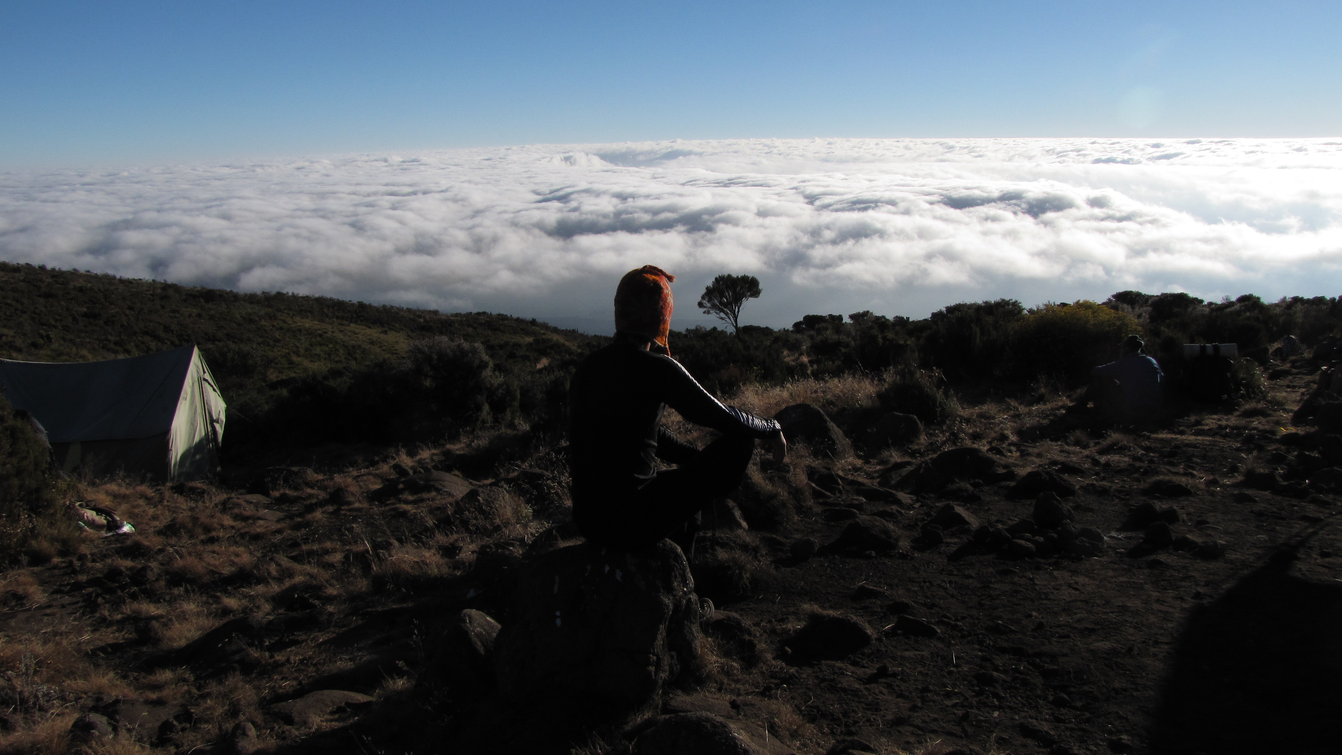

MT. KILIMANJARO MARANGU 6 DAY 5 NIGHT TREK

Marangu Route, commonly known as the Coca Cola route is more popular because it can be done in fewer days and has permanent sleep huts at the campsites.
Summit night from Kibo Hut is steep and passes Gilman’s Point to Uhuru Peak. It is a shorter route with a steeper incline and less time for acclimatization it tends to have a lower summit success rate. This is the only route where the ascent and descent route is shared, thus creating more traffic.

Duration: 5 or 6 days
Difficulty: Medium
Scenery: Good
Traffic: High

Upon arrival to Kilimanjaro International Airport, you will be met and transferred for overnight accommodation at Kilimanjaro Wonders Hotel 4stars B&B. Your head guide will meet you for your briefing, gear check and arrange for you to hire any equipment you may need.

DAY 1: MARANGU GATE – MANDARA HUTS: 8.3km /5mi | 4-5 hrs | Rainforest
Elevation: 1905m/6250ft to 2723m/8934ft
Altitude gained: 818m

Departing from Moshi a 45-minute drive will take you through the Village of Machame to the Kilimanjaro National Park Gate. We will patiently wait for our permits to be issued while watching the hustle and bustle of operations as many crews prepare for the journey ahead Enjoy the beautiful rainforest scenery and windy trails while your guide tells you about the local flora and fauna and natural wildlife. At these lower elevations the trail can be muddy and quite slippery. We highly recommend gaiters and trekking poles here.

DAY 2: MANDARA HUTS – HOROMBO HUTS: 12.5km/7.8mi | 6-8hrs | Mooreland
Elevation: 2723m/8934ft to 3721m/12,208ft
Altitude gained: 998m
After a good nights sleep and a hearty breakfast we emerge from the rain forest and continue on an ascending path, through heath land, looking for giant lobelias and groundsels. Continue up into open moorlands where small shrubs are the main vegetation. Stop halfway for lunch, to enjoy amazing views of Mawenzi. Arrive at the Horombo Huts late afternoon beneath the spectacular Kibo Summit viewpoint. Temperatures begin to drop.

DAY 3: HOROMBO HUTS
You can spend a full day and a second night at Horombo. On this day, you can either rest at the huts or take a stroll up to the Mawenzi base camp then return to the Horombo Huts. This extra day will help your acclimatization, and further your understanding of the mountains weather and altitude. After your pause, you will continue up to the Kibo Huts on your fourth day for your midnight start to the summit.

DAY 4: HOROMBO HUTS- KIBO HUTS: 10.5km/6mi | 6-8hrs | Semi Desert
Elevation: 3721m/12,208ft to 4714m/15,466ft
Altitude gained: 993m
After breakfast, we continue on through the dwindling heath land that blends into a moonscape as you enter the sweeping saddle connecting Mawenzi and Kibo. Here while we stop for lunch, and later when you cross this surprisingly large saddle, you can examine the summit climb up Kibo that you will be starting in just a few hours.

DAY 5: KIBO HUTS – SUMMIT: 6.25km /3.9 mi up | 5-7hrs | - HOROMBO HUTS: 15.75km /9mi down | 5-6hrs | Glaciers, Snow Capped Summit
Elevation: 4714m/15,466ft to 5895m/19,341ft
Altitude gained: 1181m
Descent to 3721m/12,208ft
Altitude lost: 2174m
Excitement is building as morning comes with an early start between midnight and 2 a.m. This is the most mentally and physically challenging portion of the trek.

We continue our way to the summit in a switchback formation through trying to stay warm and focused of the amazing sense of accomplishment that lies ahead. With a switchback motion we ascend through heavy scree and possibly snow towards Gillmans Point on the crater rim. You will be rewarded with the most magnificent sunrise during your short rest here. Faster hikers may view the sunrise from the summit. From here on your remaining 1 hour ascent to Uhuru Peak, you are likely to encounter snow all the way.

Congratulations, one step at a time you have now reached Uhuru Peak the highest point on Mount Kilimanjaro and the entire continent of Africa!

After photos, celebrations and maybe a few tears of joy we take a few moments to enjoy this incredible accomplishment. We begin our steep descent down to Mweka Camp, stopping at Barafu for lunch and a very brief rest. We strongly recommend gaiters and trekking poles for uncooperative loose gravel and volcano ash terrain. Well-deserved rest awaits you to enjoy your last evening on the mountain. Overnight Mweka Camp.

DAY 6: HOROMBO HUTS – MARANGU GATE – MOSHI: 20km/12.5mi |6-7hrs | Rainforest
Elevation: 3721m/12,208 to 1905m/6250ft
Altitude lost: 1816m
After breakfast and a heartfelt ceremony of appreciation and team bonding with your crew it’s time to say goodbye. We continue the descent down stopping at the Mandara Huts for lunch. Remember to tip your guides, cooks, and porters, since you will be leaving them here. You return back to the Marangu Park Gate and receive your summit certificates. As the weather is drastically warmer, the terrain is wet, muddy and steep and we highly recommend Gaiters and trekking poles. From the gate, a vehicle will meet you to drive you back to your hotel in Moshi (about 45 minutes). Enjoy a long over due hot shower, dinner and celebrations!!

Overnight Kilimanjaro Wonders Hotel 4stars B&B. before being transferred to your journey home, safari or relaxing trip to Zanzibar.

CERTIFIED ETHICAL CLIMBING:

We believe the tourism industry has an obligation and a great opportunity to protect the world’s natural habitats, cultural heritage sites and communities. We actively promote environmental sustainability and social responsibility.

As a Partner for Responsible Travel, we are proud members and active supporters of the
The Kilimanjaro Porters Assistance Project, (KPAP) an initiative of the International Mountain Explorers Connection, (IMEC). KPAP raises public awareness regarding the proper treatment of porters on Kilimanjaro and assists climbing companies with implementing procedures that ensure fair and ethical treatment of their porters.

Every climb is audited to ensure crewmembers are provided proper salaries, tips, food, equipment and sleeping conditions. We think it’s pretty great and our clients do as well, check out our Tripadvisor profile to see what people are saying about us.

INCLUDED IN TREKKING PACKAGE:
- Kilimanjaro trekking according to the itinerary
- Professional, English-speaking Wilderness First Responder & CPR certified Guide
- Proper Ration of Mountain crew (Cook & Porters)
- Pre and Post accommodations (2 nights Bed and Breakfast)
- Airport Transfers
- Meals according to the itinerary
- Drinking water and Full Board meals
- All National Park & Hut Fees, Crew Permits and VAT
- Rescue Fees and Emergency Evacuation Coverage with AMREF
- Fair and Sustainable Salary Crew Wages
- Gate Transfers
- Complimentary Oxygen Cylinder

EXCLUDED FROM TREKKING PACKAGE:
- Flights
- Visa fees
- Travel Insurance (Required)
- Gamow Bag
- Medication
- Tips for porters and mountain crew (20% Industry Standard Recommended)
- Personal spending money for souvenirs etc.
- Energy food & beverages, alcoholic and soft drinks
- Personal hire gear such as trekking poles, sleeping bags, etc.
- Additional lodge nights if early decent from the mountain $ 150 per room
TREKKING COSTS:

Marangu 6 days 5 nights $2,000 per person
Solo climber add on charge $280
CREW LIST IDEA FOR 2 CLIENT IS PER BELLOW :
1 Lead guide
1 Assistance guide
1 Cook
1 Waiter
8 Regular porters.

Prices quoted are subject to current Government Regulated Park Fees at time of departure
Group Discounts apply to 6 or more people is 5% only.

KNOW BEFORE YOU GO:

Weather

Responsible Travel

Tanzania Travel Facts

What to Pack

Safety

Meals On The Mountain

