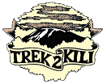
Trek2Kili
P.O. Box 2112 Moshi TZ
Cell+255673360715
trek2kili@gmail.com

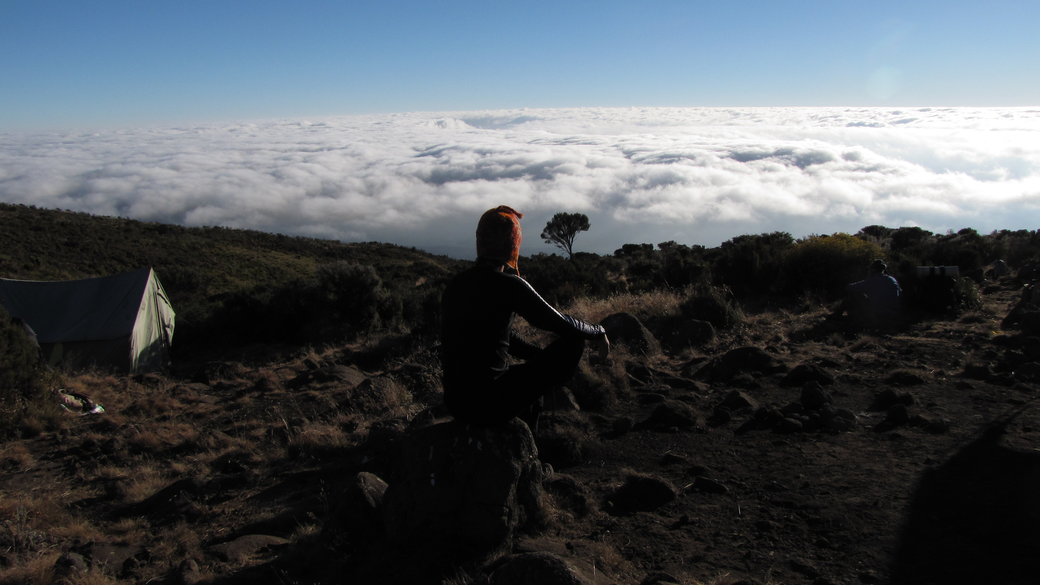

MT. KILIMANJARO RONGAI 6 DAY 5 NIGHT TREK

Less crowded because of its remote location the route offers trekkers a unique wilderness experience where it is possible to see large wildlife like antelope, elephant and buffalo. While it is flatter, it does not give the climb high sleep low option and therefore recommended to select more days for acclimatization.

The Rongai route is one of the easier routes up Kilimanjaro. Rongai is the only route to approach Kilimanjaro from the north and the descent is via the Marangu Route.

Duration: 6 or 7 days
Difficulty: Medium
Scenery: Excellent
Traffic: Low

Upon arrival to Kilimanjaro International Airport, you will be met and transferred for overnight accommodation at Kilimanjaro Wonders Hotel 4stars B&B. Your head guide will meet you for your briefing, gear check and arrange for you to hire any equipment you may need.

DAY 1: NALE MURU GATE - SIMBA CAMP: 7km /5mi | 3-4 hrs | Rainforest
Elevation: 1997m/6552ft to 2635m/8645ft
Altitude gained: 638m

Departing from Moshi a 4-5 hour drive will take you through the coffee plantations and Village of Nale Muru to the Kilimanjaro National Park Gate. We will patiently wait for our permits to be issued while watching the hustle and bustle of operations as many crews prepare for the journey ahead Enjoy the beautiful wooded scenery, and windy trails while your guide tells you about the local flora and fauna and natural wildlife you are likely to see. Simba camp sits near the first cave at the edge of the moorland zone with spectacular views of the plains of Kenya.

DAY 2: SIMBA CAMP – SECOND CAVE CAMP: 5.8km/3.6mi | 5-6hrs | Moorland
Elevation: 2635m/8645ft to 3487m/11,440ft
Altitude gained: 852m
After a good night sleep and a hearty breakfast we continue along moorland terrain on a consistent ascending path. You will catch some terrific views of Kibo and get your first glimpse of the ice fields on the Eastern crater rim. The small shrubs of the moorland became thinner as you approve the Second Cave. Temperatures begin to drop.

DAY 3: SECOND CAVE CAMP – THIRD CAVE CAMP: 3.3km/2mi | 3-4hrs | Semi Desert
Elevation: 2635m/8645ft to 3936m/12,913ft
Altitude gained: 449m
After breakfast and packing, you continue your stead ascent, entering into the semi-desert terrain. This relatively short hiking day brings you closer to the Easter ice fields, continually drawing your attention to their beauty. Pay attention to your body and keep your guide informed of any signs of altitude sickness.

DAY 4: THIRD CAVE CAMP- KIBO HUTS: 6.7km/4.2mi | 4-5hrs | Alpine Desert
Elevation: 3936m/12,913ft to 5174m/16975ft
Altitude gained: 1238m
As you depart early the semi-desert zone from the Third Cave early in the morning and begin your trek into the Alpine Desert terrain for the remainder of your ascent. Today’s hike will take you just below the Kibo crater wall to the Kibo Huts. At this point, you will merge with the Marangu Route, which you will use to hike to the summit. You will prepare your clothing and equipment (replace batteries for headlamp and camera) before you go to bed by 7 PM and try to catch a few hours of rest before your summit attempt.

DAY 5: KIBO HUTS – SUMMIT: 4km /2.5 mi up | 5-7hrs | - HOROMBO HUTS: 15.75km /9.8mi down | 5-6hrs | Glaciers, Snow Capped Summit
Elevation: 5174m/16975ft to 5895m/19,341ft
Altitude gained: 721m
Descent to 3721m/12,208ft
Altitude lost: 2174m

Excitement is building as morning comes with an early start between midnight and 2 a.m. This is the most mentally and physically challenging portion of the trek.

We continue our way to the summit between the Rebmann and Ratzel glaciers trying to stay warm and focused of the amazing sense of accomplishment that lies ahead. With a switchback motion in a northwesterly direction and ascend through heavy scree towards Stella Point on the crater rim. You will be rewarded with the most magnificent sunrise during your short rest here. Faster hikers may view the sunrise from the summit. From here on your remaining 1 hour ascent to Uhuru Peak, you are likely to encounter snow all the way.

Congratulations, one step at a time you have now reached Uhuru Peak the highest point on Mount Kilimanjaro and the entire continent of Africa!

After photos, celebrations and maybe a few tears of joy we take a few moments to enjoy this incredible accomplishment. We begin our steep descent down to Mweka Camp, stopping at Barafu for lunch and a very brief rest. We strongly recommend gaiters and trekking poles for uncooperative loose gravel and volcano ash terrain. Well-deserved rest awaits you to enjoy your last evening on the mountain. Overnight Mweka Camp.

DAY 6: HOROMBO HUTS – MARANGU GATE – MOSHI: 20km/12.5mi |6-7hrs | Rainforest
Elevation: 3721m/12,208ft to 1905m/6250ft
Altitude lost: 1816m
After breakfast and a heartfelt ceremony of appreciation and team bonding with your crew it’s time to say goodbye. We continue the descent down stopping at the Mandara Huts for lunch. Remember to tip your guides, cooks, and porters, since you will be leaving them here. You return back to the Marangu Park Gate and receive your summit certificates. As the weather is drastically warmer, the terrain is wet, muddy and steep and we highly recommend Gaiters and trekking poles. From the gate, a vehicle will meet you to drive you back to your hotel in Moshi (about 45 minutes). Enjoy a long over due hot shower, dinner and celebrations!!

Overnight Kilimanjaro Wonders Hotel 4stars B&B. before being transferred to your journey home, safari or relaxing trip to Zanzibar.

CERTIFIED ETHICAL CLIMBING:

We believe the tourism industry has an obligation and a great opportunity to protect the world’s natural habitats, cultural heritage sites and communities. We actively promote environmental sustainability and social responsibility.

As a Partner for Responsible Travel, we are proud members and active supporters of the
The Kilimanjaro Porters Assistance Project, (KPAP) an initiative of the International Mountain Explorers Connection, (IMEC). KPAP raises public awareness regarding the proper treatment of porters on Kilimanjaro and assists climbing companies with implementing procedures that ensure fair and ethical treatment of their porters.

Every climb is audited to ensure crewmembers are provided proper salaries, tips, food, equipment and sleeping conditions. We think it’s pretty great and our clients do as well, check out our Tripadvisor profile to see what people are saying about us.

INCLUDED IN TREKKING PACKAGE:
- Kilimanjaro trekking according to the itinerary
- Professional, English-speaking Wilderness First Responder & CPR certified Guide
- Proper Ration of Mountain crew (Cook & Porters)
- Pre and Post accommodations (2 nights Bed and Breakfast)
- Airport Transfers
- Meals according to the itinerary
- Drinking water and Full Board meals
- All National Park & Camping Fees, Crew Permits and VAT
- Rescue Fees and Emergency Evacuation Coverage with AMREF
- Fair and Sustainable Salary Crew Wages
- Gate Transfers
- Complimentary Oxygen Cylinder
- Portable Private Toilet and Porter
- Quality Imported Equipments

EXCLUDED FROM TREKKING PACKAGE:
- Flights
- Visa fees
- Travel Insurance (Required)
- Gamow Bag
- Medication
- Tips for porters and mountain crew (20% Industry Standard Recommended)
- Personal spending money for souvenirs etc.
- Energy food & beverages, alcoholic and soft drinks
- Personal hire gear such as trekking poles, sleeping bags, etc.
- Additional lodge nights if early decent from the mountain $ 150
TREKKING COSTS:

Rongai 6 days 5 nights $2,250 per person
Solo climber add on charge $280
CREW LIST IDEA FOR 2 CLIENT IS PER BELLOW :
1 Lead guide
1 Assistance guide
1 Cook
1 Waiter
1Toilet porter magic word (Pilot)
10 Regular porters.

Prices quoted are subject to current Government Regulated Park Fees at time of departure
Group Discounts apply to 6 or more people is 5% only.

KNOW BEFORE YOU GO:

Weather

Responsible Travel

Tanzania Travel Facts

What to Pack

Safety

Meals On The Mountain

