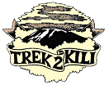
Trek2Kili
P.O. Box 2112 Moshi TZ
Cell+255673360715
trek2kili@gmail.com

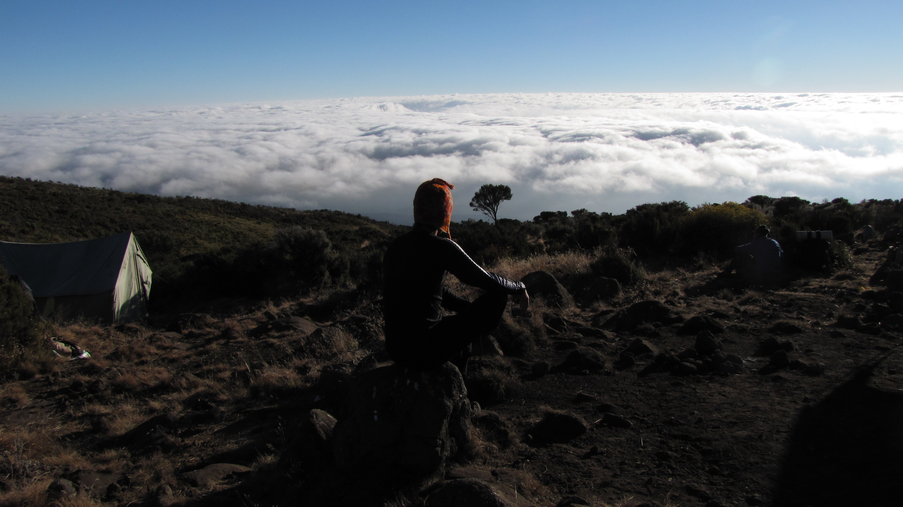

MT. KILIMANJARO UMBWE 6 DAY 5 NIGHT TREK

This route is the steepest with the shortest and most direct routes to the Southern Glaciers, Western Breach and Uhuru Peak. It is probably the most scenic, non-technical route on Kilimanjaro. However it is quite taxing, primarily due to the relatively fast ascent to higher altitude, but the rewards are plentiful. Very steep route best suited to experienced trekkers.

Duration: 6 -7 days
Difficulty: Very High
Scenery: Very Good
Traffic: Very Low

Upon arrival to Kilimanjaro International Airport, you will be met and transferred for overnight accommodation at Kilimanjaro Wonders Hotel 4stars B&B. Your head guide will meet you for your briefing, gear check and arrange for you to hire any equipment you may need.

DAY 1: UMBWE GATE – UMBWE CAVE: 9.6km/6mi | 6-8hrs | Moorland
Elevation: 1651m/5417ft to 2944m/9659ft
Altitude gained: 1293m

Departing from Moshi driving to the Kilimanjaro National Park Gate. We will patiently wait for our permits to be issued while watching the hustle and bustle of operations as many crews prepare for the journey ahead Enjoy the beautiful rainforest scenery and windy trails while your guide tells you about the local flora and fauna and natural wildlife. At these lower elevations the trail can be muddy and quite slippery. We highly recommend gaiters and trekking poles here. The path follows a ridge between two deep valleys up through the dense montane forest. The camp is perched between huge trees and thick undergrowth.

DAY 2: UMBWE CAVE – BARRANCO CAMP: 4.75km/3mi | 4-6hrs | Moorland
Elevation: 2944m/9659ft to 3986m/13,077ft
Altitude gained: 1042m
After a good nights sleep and a hearty breakfast we emerge from the rain forest and continue on a steep ascending path, along the Umbwe ridge as it descends slightly to Barranco camp situated in the valley. Temperatures begin to drop.

DAY 3: BARRANCO CAMP - KARANGA CAMP: 5.2km/3mi | 3-4hrs | Alpine Desert
Elevation: 3986m/13,077ft to 4034m/13,235ft
Altitude gained: 48m
After breakfast, we continue on a steep ridge up the adventurous Barranco Wall to the Karanga Valley and the junction, which connects, with the Mweka Trail. This is one of the most impressive days to see the power, agility, and strength of your crew zip over this wall with what appears such ease. Overnight at Karanga Camp.

DAY 4: KARANGA CAMP - BARAFU CAMP: 3.3km /2 mi | 3-4hrs | Alpine Desert
Elevation: 4034m/13,235ft to 4662m/15,295ft
Altitude gained: 628m
We continue up toward Barafu Camp, and once reached you have now completed the South Circuit, which offers a variety of breathtaking views of the summit from many different angles. An early dinner and rest as we prepare for summit night. Overnight at Barafu Camp.

DAY 5: BARAFU CAMP – SUMMIT: 4.86km /3mi up | 5-7hrs | - MWEKA CAMP: 11.5km /7.1mi down | 5-6hrs | Glaciers, Snow Capped Summit
Elevation: 4662m/15,295ft to 5895m/19,341ft
Altitude gain: 1233m
Descent to 3106m/10,190ft
Altitude lost: 2789m
Excitement is building as morning comes with an early start between midnight and 2 a.m. This is the most mentally and physically challenging portion of the trek.

We continue our way to the summit between the Rebmann and Ratzel glaciers trying to stay warm and focused of the amazing sense of accomplishment that lies ahead. With a switchback motion in a northwesterly direction and ascend through heavy scree towards Stella Point on the crater rim. You will be rewarded with the most magnificent sunrise during your short rest here. Faster hikers may view the sunrise from the summit. From here on your remaining 1 hour ascent to Uhuru Peak, you are likely to encounter snow all the way.

Congratulations, one step at a time you have now reached Uhuru Peak the highest point on Mount Kilimanjaro and the entire continent of Africa!

After photos, celebrations and maybe a few tears of joy we take a few moments to enjoy this incredible accomplishment. We begin our steep descent down to Mweka Camp, stopping at Barafu for lunch and a very brief rest. We strongly recommend gaiters and trekking poles for uncooperative loose gravel and volcano ash terrain. Well-deserved rest awaits you to enjoy your last evening on the mountain. Overnight Mweka Camp.

DAY 6: MWEKA CAMP - MWEKA GATE – MOSHI: 9.1km/5.7mi |3-4hrs | Rainforest
Elevation: 3106m/10,190ft to 1633m/5358ft
Altitude lost: 1473m
After breakfast and a heartfelt ceremony of appreciation and team bonding with your crew it’s time to say goodbye. We continue the descent down to the Mweka Park Gate to receive your summit certificates. As the weather is drastically warmer, the terrain is wet, muddy and steep and we highly recommend Gaiters and trekking poles.

From the gate, a vehicle will meet you at Mweka village to drive you back to your hotel in Moshi (about 30 minutes). Enjoy a long over due hot shower, dinner and celebrations!!

Overnight Kilimanjaro Wonders Hotel 4stars B&B. before being transferred to your journey home, safari or relaxing trip to Zanzibar.

CERTIFIED ETHICAL CLIMBING:

We believe the tourism industry has an obligation and a great opportunity to protect the world’s natural habitats, cultural heritage sites and communities. We actively promote environmental sustainability and social responsibility.

As a Partner for Responsible Travel, we are proud members and active supporters of the
The Kilimanjaro Porters Assistance Project, (KPAP) an initiative of the International Mountain Explorers Connection, (IMEC). KPAP raises public awareness regarding the proper treatment of porters on Kilimanjaro and assists climbing companies with implementing procedures that ensure fair and ethical treatment of their porters.

Every climb is audited to ensure crewmembers are provided proper salaries, tips, food, equipment and sleeping conditions. We think it’s pretty great and our clients do as well, check out our Tripadvisor profile to see what people are saying about us.

INCLUDED IN TREKKING PACKAGE:
- Kilimanjaro trekking according to the itinerary
- Professional, English-speaking Wilderness First Responder & CPR certified Guide
- Proper Ration of Mountain crew (Cook & Porters)
- Pre and Post accommodations (2 nights Bed and Breakfast)
- Airport Transfers
- Meals according to the itinerary
- Drinking water and Full Board meals
- All National Park & Camping Fees, Crew Permits and VAT
- Rescue Fees and Emergency Evacuation Coverage with AMREF
- Fair and Sustainable Salary Crew Wages
- Gate Transfers
- Complimentary Oxygen Cylinder
- Portable Private Toilet and Porter
- Quality Imported Equipments

EXCLUDED FROM TREKKING PACKAGE:
- Flights
- Visa fees
- Travel Insurance (Required)
- Gamow Bag
- Medication
- Tips for porters and mountain crew (20% Industry Standard Recommended)
- Personal spending money for souvenirs etc.
- Energy food & beverages, alcoholic and soft drinks
- Personal hire gear such as trekking poles, sleeping bags, etc.
- Additional lodge nights if early decent from the mountain $ 150 per room
TREKKING COSTS:

Umbwe 6 days 5 nights $2,550 per person
Solo climber add on charge $320
Single supplement charge $280

CREW LIST IDEA FOR 2 CLIENT IS PER BELOW :
1 Lead guide
1 Assistance guide
1 Cook
1 Waiter
1Toilet porter magic word (Pilot)
10 Regular porters.

Prices quoted are subject to current Government Regulated Park Fees at time of departure
Group Discounts apply to 6 or more people is 5% only.

KNOW BEFORE YOU GO:

Weather

Responsible Travel

Tanzania Travel Facts

What to Pack

Safety

Meals On The Mountain

