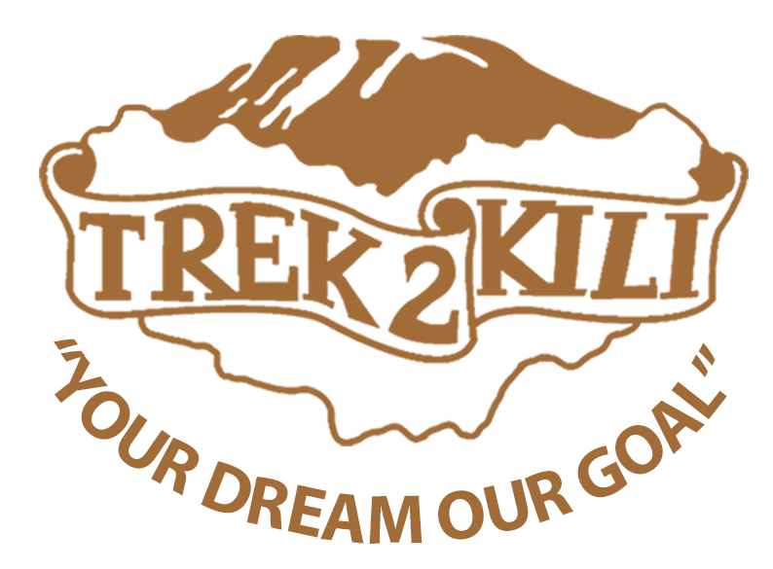
Trek2Kili
P.O. Box 2112 Moshi TZ
Cell+255673360715
trek2kili@gmail.com
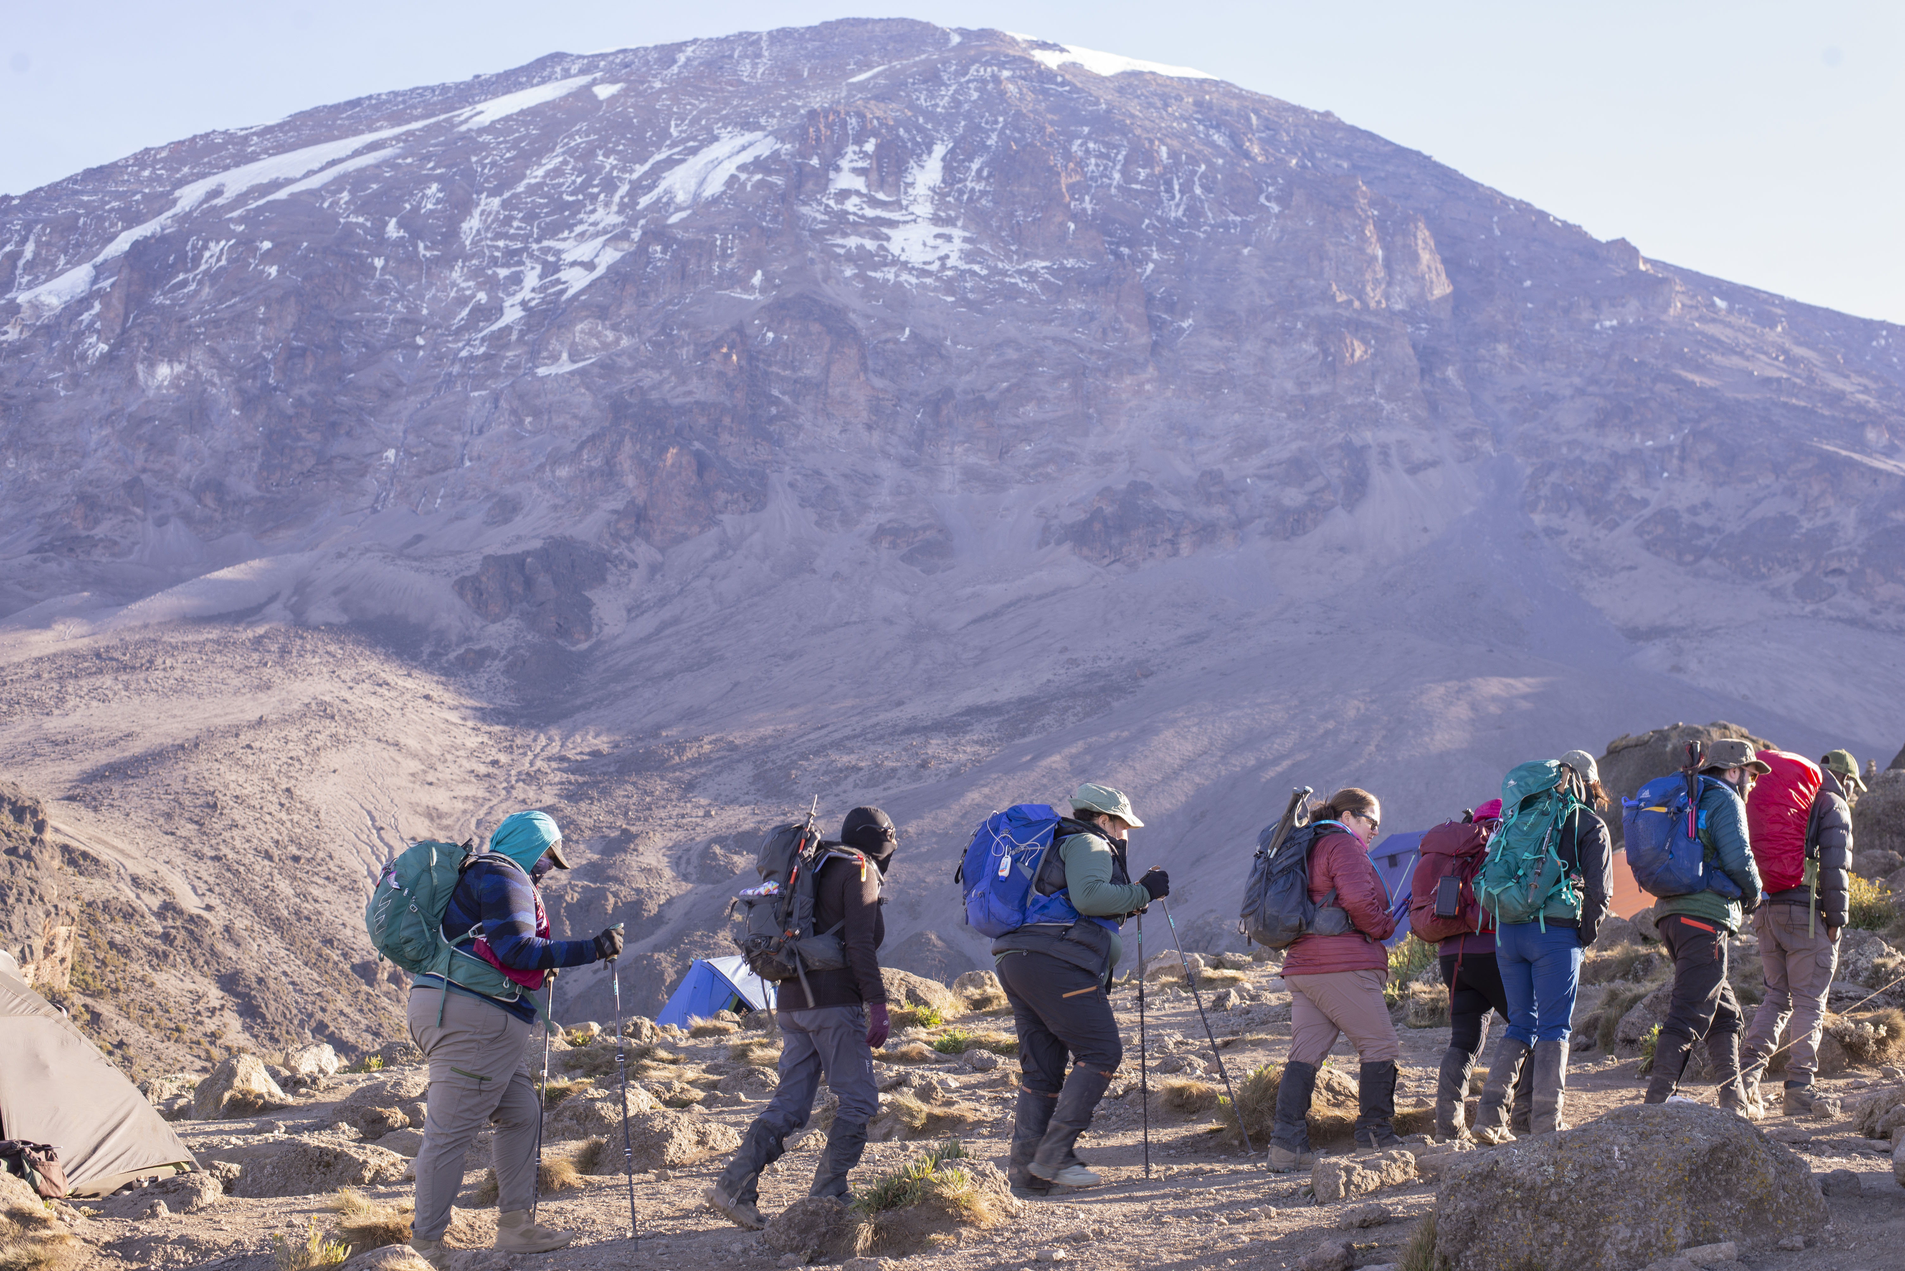

MT. KILIMANJARO MACHAME 8 DAY 7 NIGHT TREK

Known as the Whisky Route, this is one of the most scenic and therefore popular routes on the mountain and offers adventurous climbers stunning scenic vistas. With paths through magnificent forests to gain a ridge leading through the moorland zones to late sunsets at Shira Plateau to the misty revelations of Kibo at the great Barranco Wall.

It then traverses beneath the glaciated precipices of the Southern Ice fields to join the Barafu Route to the summit. Because it can be done over longer periods and the incline is more manageable it has a much higher success rate of summit.

Duration: 8 days
Difficulty: Medium
Scenery: Excellent
Traffic: High

Day 1:Upon arrival to Kilimanjaro International Airport, you will be met and transferred for overnight accommodation at KILIMANJARO WONDERS HOTEL MOSHI B&B.

Day 2: At 7:30 am you will depart to Materuni and Coffee Tour Experience which the drive will take 30 minutes to the starting point of walking to the waterfalls and the walking will take 2 hours one way so total of 4 hours walk then drive for 15 minutes to meet our best local coffee Experience guide Exaudi family who will gives you the best class for coffee and you can support them by purchase the Aroma coffee from them.

After the coffee Experince will drive back to town for Lunch at the Indotaliano Restaurant in Moshi town

After Lunch you will back at the Hotel for briefing, gear check and arrange for you to hire any equipment you may need.

DAY 3: MACHAME GATE - MACHAME CAMP: 10.75k /7mi | 5-6 hrs | Rainforest
Elevation: 1811m/5942ft to 3021m/9911ft
Altitude gained: 1210m

Departing from Moshi a 45-minute drive will take you through the Village of Machame to the Kilimanjaro National Park Gate. We will patiently wait for our permits to be issued while watching the hustle and bustle of operations as many crews prepare for the journey ahead Enjoy the beautiful rainforest scenery and windy trails while your guide tells you about the local flora and fauna and natural wildlife. At these lower elevations the trail can be muddy and quite slippery. We highly recommend gaiters and trekking poles here.

DAY 4: MACHAME CAMP - SHIRA CAMP: 5.3km/3mi | 4-5hrs | Moorland
Elevation: 3021m/9911ft to 3839m/12,595ft
Altitude gained: 818m
After a good nights sleep and a hearty breakfast we emerge from the rain forest and continue on an ascending path, crossing the valley along a steep rocky ridge. The route now turns west onto a river gorge until we arrive at the Shira campsite. Temperatures begin to drop.

DAY 5: SHIRA CAMP - LAVA TOWER - BARRANCO CAMP: 10.75km/6mi | 5-6hrs | Semi Desert
Elevation: 3839m/12,595ft to 3986m/13,077ft
Altitude gained: 147m
Although you end the day around the same elevation as when you began, this day is very important for acclimatization. From Shira Plateau we continue east up a ridge, passing the junction towards the Kibo peak before we then continue, South East towards the Lava Tower, called the “Shark’s Tooth” (elev. 4650m/15,250ft). Shortly after the tower we come to a second junction, which leads to the Arrow Glacier. We then continue to descend to overnight at Barranco Camp.

DAY 6: BARRANCO CAMP - KARANGA CAMP: 5.2km/3mi | 3-4hrs | Alpine Desert
Elevation: 3986m/13,077ft to 4034m/13,235ft
Altitude gained: 48m
After breakfast, we continue on a steep ridge up the adventurous Barranco Wall to the Karanga Valley and the junction, which connects, with the Mweka Trail. This is one of the most impressive days to see the power, agility, and strength of your crew zip over this wall with what appears such ease. Overnight at Karanga Camp.

DAY 7: HIKE KARANGA CAMP – COSOVO CAMP: 3.8km /2.4 mi | 3-4hrs | Alpine Desert
Elevation: 4034m/13,235ft to 4870m/15,987ft
Altitude gained: 836m
We continue up toward Cosovo Camp, and once reached you have now completed the South Circuit, which offers a variety of breathtaking views of the summit from many different angles. An early dinner and rest as we prepare for summit night. Overnight at Cosovo Camp.

DAY 8: COSOVO CAMP – SUMMIT: 4.50km /3mi up | 5-7hrs | - Glaciers, Snow Capped Summit
The Summit depart at 4am heading to Uhuru peak then will be back to overnight at Barafu camp for overnight

Day 9: BARAFU CAMP : Once back from the Summit you will sleep at the Barafu Camp which is 200m from Cosovo Camp

Day 10: BARAFU CAMP -MWEKA CAMP: 13km /8mi down | 5-6hrs | Glaciers, Snow Capped Summit
Elevation: 4662m/15,295ft to 5895m/19,341ft
Altitude gained: 1233m
Descent to 3106m/10,190ft
Altitude lost: 2789m

Day 11: DAY 8: MWEKA CAMP - MWEKA GATE – MOSHI: 9.1km/6mi |3-4hrs | Rainforest
Elevation: 3106m/10,190ft to 1633m/5358ft
Altitude lost: 1473m
After breakfast and a heartfelt ceremony of appreciation and team bonding with your crew it’s time to say goodbye. We continue the descent down to the Mweka Park Gate to receive your summit certificates. As the weather is drastically warmer, the terrain is wet, muddy and steep and we highly recommend Gaiters and trekking poles.

From the gate to the office its 30 minutes where you will have lunch with your crew and give gratitude to them, you are welcome to bring gift from your country home to give to your crew also

Overnight KILIMANJARO WONDERS HOTEL MOSHI B&B. before being transferred to your journey home, safari or relaxing trip to Zanzibar.

INCLUDED IN TREKKING PACKAGE:
- Kilimanjaro trekking according to the itinerary
- Professional, English-speaking Wilderness First Responder & CPR certified Guide
- Proper Ration of Mountain crew (Cook & Porters)
- Pre and Post accommodations (3 nights Bed and Breakfast)
- Materuni and Coffe Experience with lunch in town
- Cosovo Camp fee
- Airport Transfers
- Meals according to the itinerary
- Drinking water and Full Board meals
- All National Park & Camping Fees, Crew Permits and VAT
- Fair and Sustainable Salary Crew Wages
- Gate Transfers
- Complimentary Oxygen Cylinder
- Portable Private Toilet and Porter
- Quality Imported Equipments
EXCLUDED FROM TREKKING PACKAGE:
- Flights
- Visa fees
- Travel Insurance (Required)
- Gamow Bag
- Medication
- Tips for porters and mountain crew (20% Industry Standard Recommended$600 USD )
- Personal spending money for souvenirs etc.
- Energy food & beverages, alcoholic and soft drinks
- Personal hire gear such as trekking poles, sleeping bags, etc.
- Additional lodge nights for acclimatize is $ 150 for one room bed breakfast
TREKKING COSTS:

Machame route package total 10 nights 11 days $3,600 per person Sharing
Single supplement charge $350

- Here is the gear list Kilimanjaro Gear
- Here is the clothing list Equipments for you to bring
- Rental list and price Gears Rental & Prices

Please provide below to book with us.
Full names, Passport copy attached, Home address & City, Nationality, Phone number, Gender's, Age, any medical issue for the past 2 years and any food restrictions

KNOW BEFORE YOU GO:

Weather

Responsible Travel

Tanzania Travel Facts

What to Pack

Safety

Meals On The Mountain

